TIMEEFECT Installation Manual

Dependencies
To run TIMEEFFECT you need a working MySQL database (version 3.23 or higher) and the ‘Auth’ (v. 1.67) and ‘DB’ (v. 1.22) packages of the PEAR framework.
You may download the MySQL database at http://www.mysql.com/ and the PEAR packages at http://pear.php.net/.
Furthermore you need a running Apache (v. 1.3 or higher) with PHP4 support. Both packages can be downloaded at http://www.apache.org/ and http://www.php.net/.

Preparation

MySQL
Before you actually install the TIMEEFFECT package you have to create a new database and a database user with SELECT, INSERT, UPDATE, DELETE rights on the created database within your MySQL system. By TIMEEFFECT system default the database name is ‘timeeffect’ and the appropriate user is ‘timeeffect’ with the password ‘PfTe04’. During installation process you may change those values.

PHP
To have TIMEEFFECT running you need to set the value of the directive register_globals in your php.ini to ‘On’ (‘register_globals = On’). You can figure out where your php.ini is located by creating a php script with the following content: <?php phpinfo(); ?>. By opening this script in your browser you will get a detailed overview of your PHP settings.

PEAR
Since version beta 1.1.a the needed PEAR files are included with TIMEEFFECT release. For previous releases you have to install the appropriate PEAR packages before TIMEEFFECT will run.
There are some issues regarding the use of PEAR packages with previous releases: PHP knows the configuration directive ‘open_basedir’, which prevents PHP scripts from accessing files which are not located within the web server’s document root or beneath. Since many hosters are using this directive for security reasons it may be necessary to install the PEAR sources within a subdirectory of the TIMEEFFECT include directory. The name of the subdirectory has to be ‘pear’.
If you are sure that your local installation of the PEAR packages is working, you may delete the subdirectory ‘pear’ within the TIMEEFFECT include directory. If you are not sure about this, just leave the include structure as it is.

Setup
For the installation of TIMEEFFECT now extract the contents of the tarball in a directory which is located beneath the document root of your web server. The extraction will create a new subdirectory named ‘timeeffect’.
Make sure that the file ‘include/aperetive.inc.php’ is writeable to your web server process.

UNIX operating systems
On UNIX operating systems proceed as follows:
If you have ssh or telnet access to your web-server and you extracted the tarball calling tar directly from ssh or telnet console, the file ‘include/aperetive.inc.php’ is writeable to any user on your web-server. To make sure that ‘include/aperetive.inc.php’ is really writeable to your web server process login to your web server change to the TIMEEFFECT installation directory and enter
ls -l include/aperetiv.inc.php
at the command prompt. If you see something like
-rw-rw-rw- 1 devel devel 6751 2004-04-07 09:36 include/aperetiv.inc.php
the file is writeable as needed. Pay attention to the beginning of the line: ‘-rw-rw-rw-‘. The third group of ‘rw-‘ letters tells you that the file is readeable ‘r’ and writeable ‘w’ to the whole world. If the line starts with something like ‘-rw-rw-r--‘ or ‘-rw-rw----‘ the file is merely writeable to the user you are logged in and the users that are members of the same group that the file belongs to. If you are sure that the file is writeable proceed with chapter ‘3.3 Installation Interface’.

Microsoft® Windows® operating systems
On Microsoft® Windows® operating systems proceed as follows:
Open the Windows® Explorer and find the TIMEEFFECT installation directory. Enter the subdirectory ‘include’ and press the right mouse key on the file ‘aperetive.inc.php’. Now select the menu ‘Properties’ (or the appropriate localized entry like ‘Eigenschaften’ for German Windows® versions). Make sure the checkbox ‘write-protected’ is not checked. If you are sure that the file is writeable proceed with chapter ‘3.3 Installation Interface’.

Installation Interface
To start the installation routine now enter he URL of your web server into the address line of your browser and add ‘/timeffect/install/’ at the end. For example: if your web server is ‘www.somedomain.com’ enter ‘http://www.somedoain.com/timeeffect/install/’ into your browser.
The installation process is divided into four steps. You are now looking at ‘Step 1’ of the TIMEEFFECT installation interface:
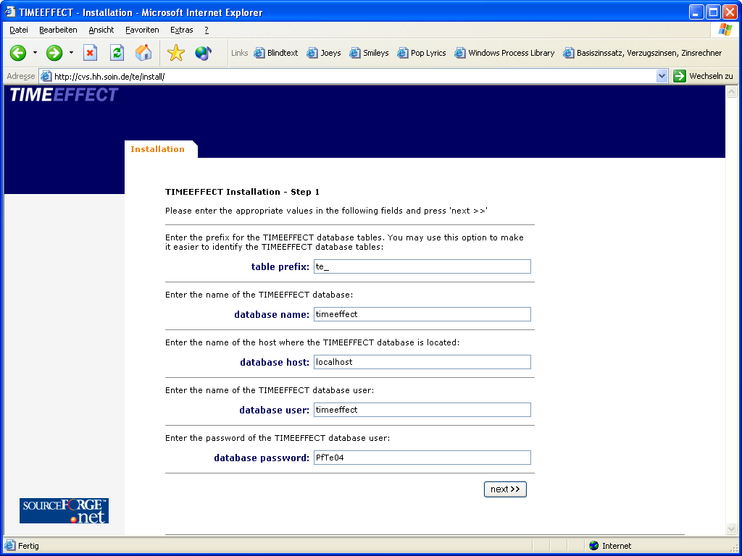
Enter the data that fits your local installation and click ‘next >>’. Proceed accordingly through ‘Step 2’. In ‘Step 3’ check whether the entered data is correct and click ‘finish >>’ to complete the setup.
If you see the following screen the TIMEEFFECT installation is complete:
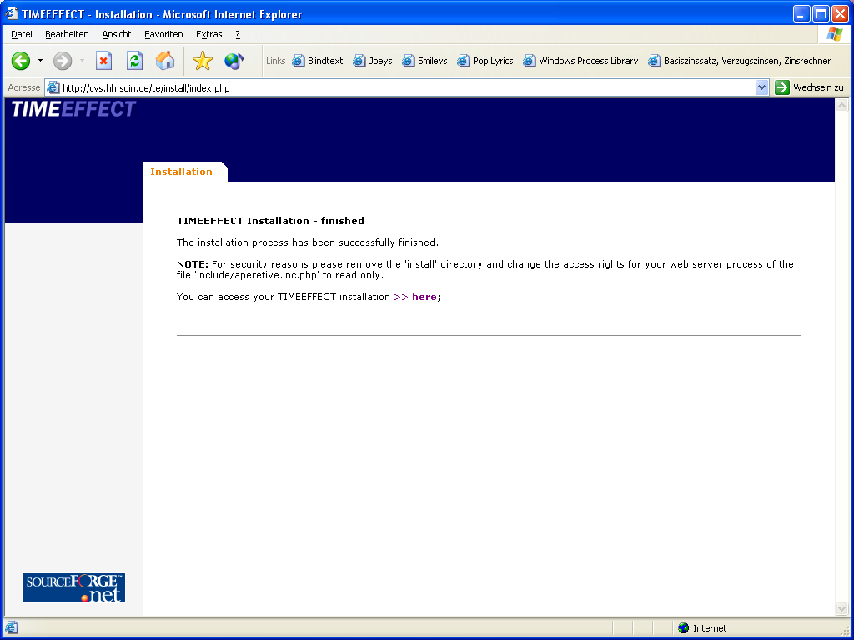
For security reasons please remove the ‘install’ subdirectory of your TIMEEFFECT installation and change the access rights of the file ‘include/aperetiv.inc.php’ so that your web server process is merely allowed to read but not write to the file.
You may see some error messages if the installation failed. Consider whatever the error messages are complaining about and try to change your local setup. Try to install TIMEEFFECT again.
If you are facing any problems during the installation of TIMEEFFECT please contact us at support@timeeffect.de.

Customizing
After installation you may change some values of your local TIMEEFFECT installation by changing the file ‘aperetiv.inc.php’ which is located in the directory ‘include’. Enter the data that matches your local installation:
- $_PJ_http_root: change this to the directory where the TIMEEFFECT files are located relative to your web server’s document root.
Default value: ‘/timeeffect’
- $_PJ_root: Usually the $_PJ_root value is automatically set to relatively to your web server’s document root. Change this to the full path to your TIMEEFFECT installation if needed.
Default value: $DOCUMENT_ROOT . '/timeeffect';
- $_PJ_language: defines the front-end language of TIMEEFFECT. Currently ‘en’ and ‘de’ are supported.
- $_PJ_db_host: the TIMEFFECT database host.
Default value: ‘localhost’
- $_PJ_db_database: database name.
Default value: ‘timeeffect’
- $_PJ_db_user: database user.
Default value: ‘timeeffect’
- $_PJ_db_password: password for the database user.
Default value: ‘PfTe04’

‘phpMyAdmin’ – a nice tool for managing MySQL databases – can be found at www.phpmyadmin.net.

